**NAME:**

**DOHA KHALID SAPER IBRIAM**

**GROUP:**

**3**

**SEC:**

**18**

**BN:**

**12**

**Code:**

**405**

TOPIC

**MOBLIE COMPUTING**

**GIT HUB LINK:** [**https://github.com/ddohakahlid/html.progect.repository**](https://github.com/ddohakahlid/html.progect.repository)

**GIT HUB PAGE:**

[**https://ddohakahlid.github.io/html.progect.repository/**](https://ddohakahlid.github.io/html.progect.repository/)

**APPLICATION briF**

**Visual studio**

**the Visual Studio integrated development environment is a creative launching pad that you can use to edit, debug, and build code, and then publish an app. An integrated development environment (IDE) is a feature-rich program that can be used for many aspects of software development. Over and above the standard editor and debugger that most IDEs provide, Visual Studio includes compilers, code completion tools, graphical designers, and many more features to ease the software development process**

**SCREEN SHOTS**

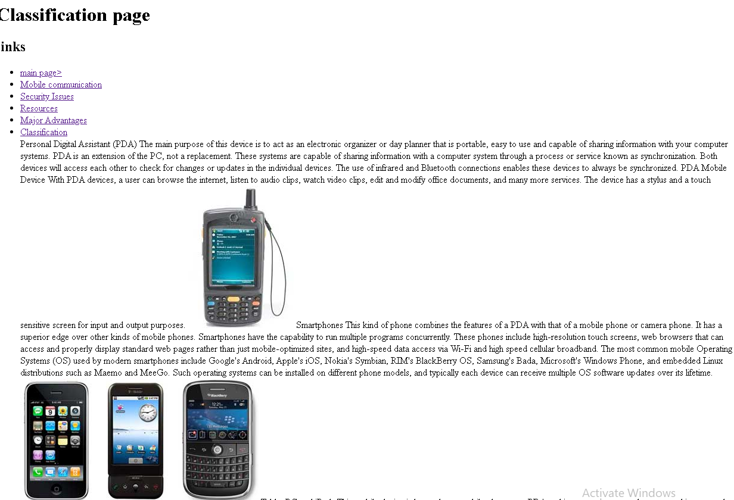

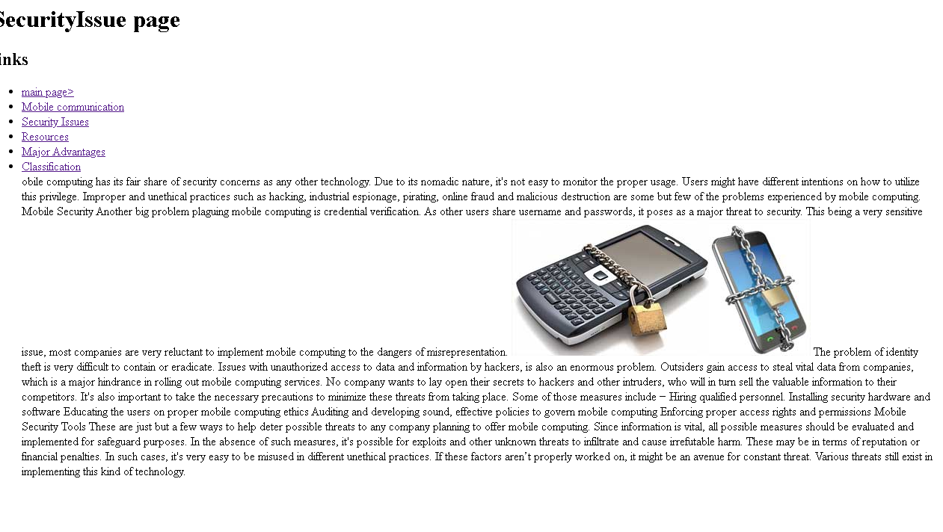

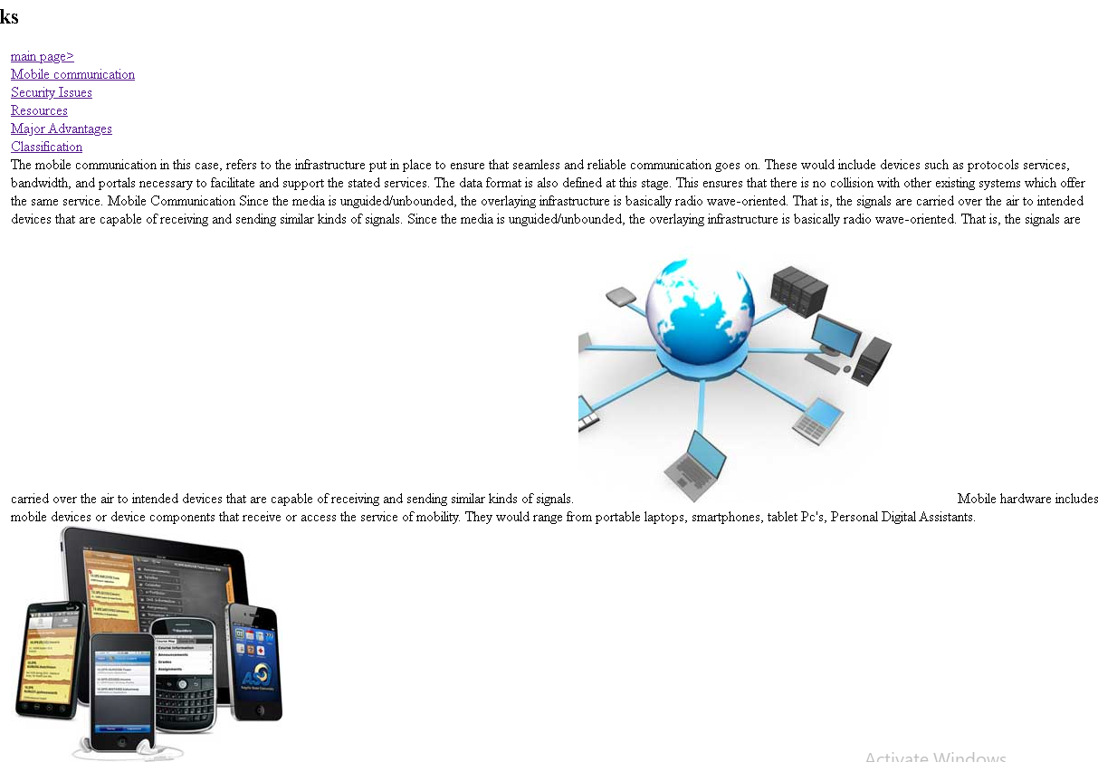

SOURCE CODE

